B.B.S.S.S.A. Netball

The venue for netball will be Pennant Hills Netball Centre, which is located left at the round-a-bout off Britannia St, Pennant Hills.

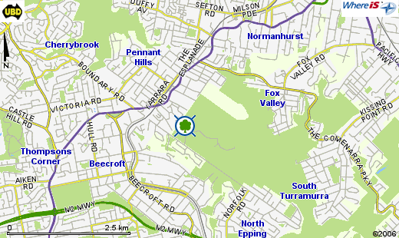

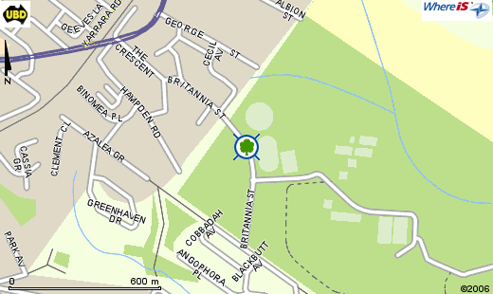
Netball
Courts

